GameLens AI - ROAS Forecasting Dashboard Usage Guide

# Overview

The GameLens AI dashboard is a comprehensive ROAS (Return on Ad Spend) forecasting platform designed for mobile game advertising optimization. This guide provides detailed instructions for using each page of the dashboard.  
  
The dashboard consists of 6 main pages accessible via the sidebar:  
1. Data Overview - Data loading and validation  
2. Feature Engineering - Data preprocessing and feature creation   
3. Model Training - Machine learning model training and configuration  
4. Predictions - ROAS predictions and model performance analysis  
5. Recommendations - Actionable insights and campaign recommendations  
6. FAQ - AI-powered question answering system

# Page 1: Data Overview 📊

## Purpose

Load, validate, and explore your advertising data from multiple platforms (Unity Ads, Mistplay, etc.).

## How to Use

1. Data Loading:

* • The system automatically scans the Campaign Data/ folder
* • Supports CSV files from Unity Ads and Mistplay platforms
* • Handles both Android and iOS data

2. Data Validation:

* • Check data quality metrics (missing values, duplicates)
* • Verify platform distribution
* • Review date ranges and sample sizes

3. Data Preview:

* • View sample records from each platform
* • Examine column structures and data types
* • Identify any data quality issues

## Key Features

* • Multi-platform support: Unity Ads, Mistplay
* • Automatic data detection: Scans for CSV files
* • Data quality metrics: Missing values, duplicates, platform distribution
* • Data preview: Sample records and column information

## What to Look For

* ✅ All expected platforms are loaded
* ✅ Data covers your desired date range
* ✅ No significant missing values or duplicates
* ✅ ROAS columns are present (roas_d0, roas_d7, roas_d30, etc.)

# Page 2: Feature Engineering 🔧

## Purpose

Transform raw advertising data into predictive features for machine learning models.

## How to Use

1. Target Day Selection:

* • Choose which ROAS day to predict (D7, D15, D30, D45, D90)
* • This determines what the model will learn to predict

2. Feature Creation:

* • Click "Create Features" to generate predictive features
* • Features include retention rates, early ROAS, level progression, cost metrics
* • Process may take a few minutes for large datasets

3. Feature Analysis:

* • Review feature summary statistics
* • Check feature importance rankings
* • Identify top predictive features

## Key Features

* • Retention features: D1, D3, D7 retention rates
* • Early ROAS indicators: D0, D3, D7 ROAS values
* • Engagement metrics: Level progression, session data
* • Cost efficiency: CPI, cost per level, revenue ratios
* • Platform-specific features: Platform performance indicators

## What to Look For

* ✅ Features created successfully (no errors)
* ✅ Reasonable feature importance scores
* ✅ Features align with your business logic
* ✅ No missing values in critical features

# Page 3: Model Training 🤖

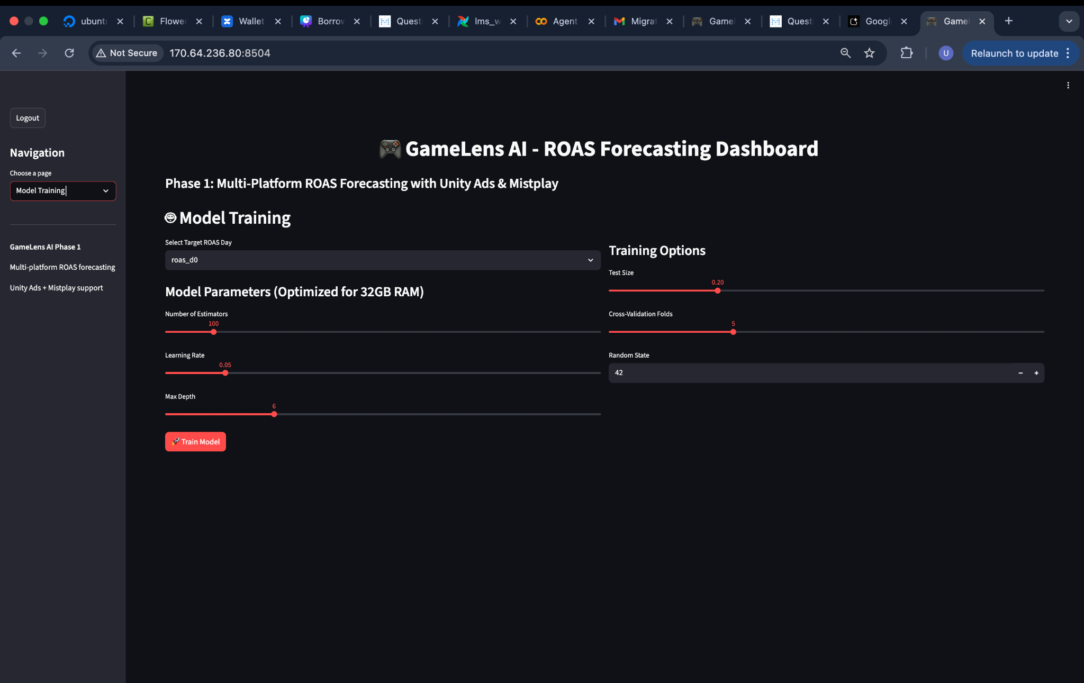

## Purpose

Train machine learning models to predict ROAS with confidence intervals.

## How to Use

1. Model Configuration:

* • Target Day: Select the ROAS day to predict
* • Number of Estimators: Trees in the model (default: 100)
* • Learning Rate: How fast the model learns (default: 0.1)
* • Max Depth: Tree depth (default: 6)
* • Random State: For reproducible results (default: 42)

2. Training Process:

* • Click "Train Model" to start training
* • Process may take 2-5 minutes depending on data size
* • Monitor progress with status messages

3. Model Validation:

* • Review training metrics (R², RMSE, MAPE, MAE)
* • Check confidence interval coverage
* • Examine feature importance rankings

## Key Features

* • Quantile Regression: Predicts ROAS with confidence intervals
* • LightGBM/XGBoost: High-performance gradient boosting
* • Feature Importance: Identifies key predictive factors
* • Model Validation: Comprehensive performance metrics

## What to Look For

* ✅ R² score > 0.3 (good model fit)
* ✅ MAPE < 50% (reasonable prediction accuracy)
* ✅ Confidence coverage ~80-90% (reliable intervals)
* ✅ Feature importance makes business sense

# Page 4: Predictions 📈

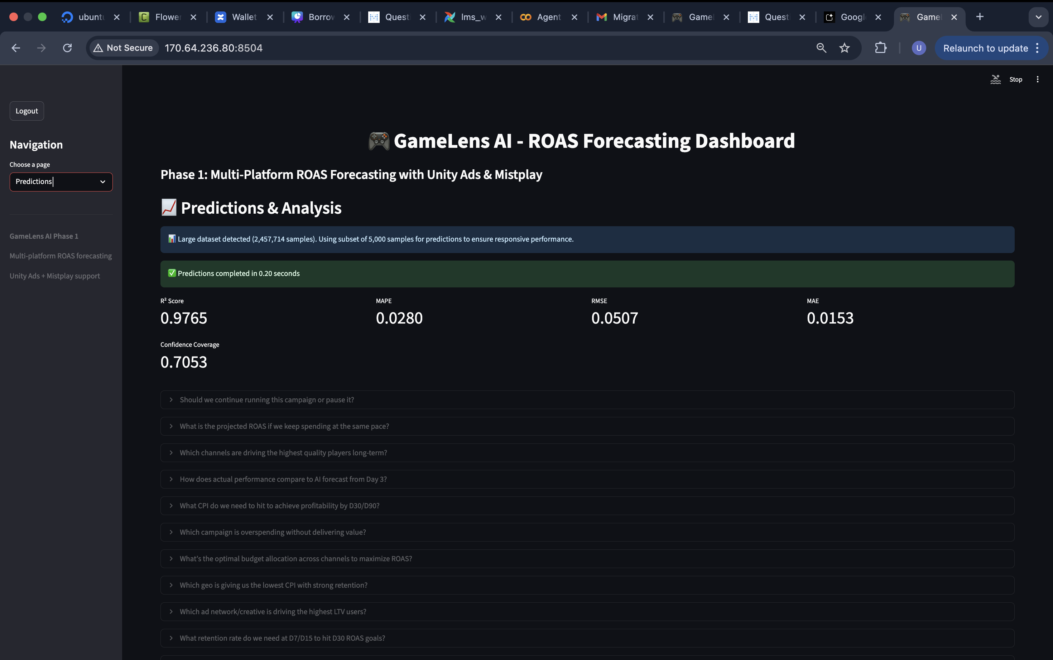

## Purpose

Generate ROAS predictions and analyze model performance on your data.

## How to Use

1. Prediction Generation:

* • Predictions are automatically generated after model training
* • Shows ROAS predictions with confidence intervals
* • Displays prediction distribution and statistics

2. Performance Analysis:

* • Review model performance metrics
* • Check prediction accuracy and confidence
* • Analyze ROAS distribution across campaigns

3. Data Insights:

* • View prediction summaries (mean, percentiles)
* • Examine confidence interval widths
* • Identify high/low performing campaigns

## Key Features

* • ROAS Predictions: Point estimates with confidence bounds
* • Performance Metrics: R², RMSE, MAPE, MAE, confidence coverage
* • Distribution Analysis: ROAS ranges and percentiles
* • Campaign Insights: High/medium/low ROAS categorization

## What to Look For

* ✅ Predictions completed successfully
* ✅ Reasonable ROAS ranges (0.1 to 5.0 typical)
* ✅ Good model performance metrics
* ✅ Confidence intervals are not too wide

# Page 5: Recommendations 💡

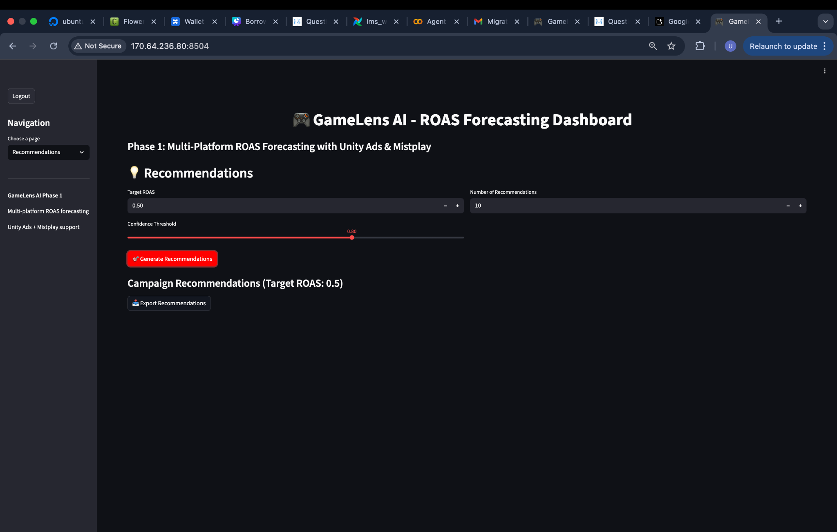

## Purpose

Generate actionable recommendations for campaign optimization based on model predictions.

## How to Use

1. Recommendation Settings:

* • Target ROAS: Set your desired ROAS goal (default: 0.5)
* • Number of Recommendations: How many to show (default: 10)
* • Confidence Threshold: Minimum confidence level (default: 0.8)

2. Generate Recommendations:

* • Click "Generate Recommendations"
* • Review campaign-specific recommendations
* • Analyze improvement potential

3. Action Planning:

* • Identify campaigns to scale or cut
* • Prioritize based on improvement potential
* • Consider confidence levels in decisions

## Key Features

* • Campaign Prioritization: Ranked by improvement potential
* • Confidence Filtering: Only high-confidence recommendations
* • ROAS Improvement: Quantified potential gains
* • Actionable Insights: Clear next steps for each campaign

## What to Look For

* ✅ Recommendations generated successfully
* ✅ Clear improvement potential for each campaign
* ✅ Confidence levels are reasonable
* ✅ Recommendations align with business goals

# Page 6: FAQ ❓

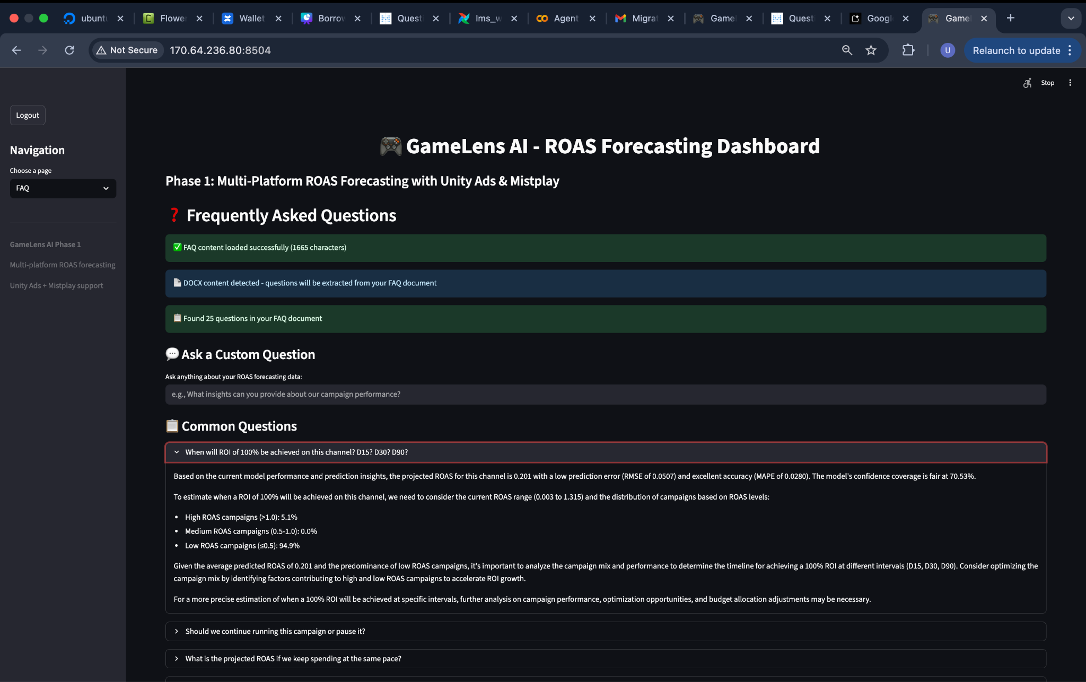

## Purpose

AI-powered question answering system that provides insights about your data and model performance.

## How to Use

1. Question Selection:

* • Browse pre-loaded questions from your FAQ document
* • Questions are automatically extracted from FAQ.docx
* • Click on any question to get an AI-powered answer

2. AI-Powered Answers:

* • Answers combine your FAQ content with current dashboard data
* • Provides data-driven insights and recommendations
* • Uses your actual model performance and predictions

3. Context-Aware Responses:

* • Answers are tailored to your specific data
* • Includes current model metrics and performance
* • Provides actionable insights based on your results

## Key Features

* • Document Integration: Reads questions from FAQ.docx
* • AI-Powered: Uses GPT for intelligent responses
* • Data-Driven: Combines FAQ knowledge with dashboard data
* • Context-Aware: Tailored to your specific results

## What to Look For

* ✅ FAQ content loaded successfully
* ✅ Questions extracted from your document
* ✅ AI answers are relevant and helpful
* ✅ Responses include your actual data insights

# Best Practices

## Data Preparation

* • Ensure data quality: Clean, complete datasets work best
* • Include sufficient history: At least 30 days of data recommended
* • Verify ROAS columns: Ensure target ROAS days are present
* • Check platform coverage: Include all relevant advertising platforms

## Model Training

* • Start with defaults: Use default parameters initially
* • Monitor performance: Watch for overfitting or underfitting
* • Validate results: Check that metrics make business sense
* • Iterate if needed: Adjust parameters based on performance

## Using Predictions

* • Consider confidence: Use confidence intervals in decision-making
* • Focus on trends: Look at patterns rather than individual predictions
* • Validate with business logic: Ensure predictions align with expectations
* • Monitor over time: Track prediction accuracy as new data comes in

## Making Recommendations

* • Set realistic targets: Use achievable ROAS goals
* • Consider confidence levels: Prioritize high-confidence recommendations
* • Balance risk/reward: Consider both potential gains and confidence
* • Test and learn: Start with small changes and scale successful ones

# Technical Requirements

## System Requirements

* • RAM: 32GB recommended for large datasets
* • Storage: Sufficient space for data files and models
* • Network: Stable internet for AI-powered FAQ (if enabled)

## Data Requirements

* • Format: CSV files with standard column names
* • Platforms: Unity Ads, Mistplay (others can be added)
* • Time Range: Minimum 30 days of historical data
* • ROAS Columns: Must include target ROAS days (D7, D15, D30, etc.)

## Optional Features

* • AI FAQ: Requires OpenAI API key for enhanced question answering
* • Advanced Analytics: Additional features available with premium data
* • Custom Models: Specialized models for specific game types

# Conclusion

This dashboard provides a complete solution for ROAS forecasting and campaign optimization. Each page builds upon the previous one, creating a comprehensive workflow from data loading to actionable recommendations.  
  
The system is designed to be user-friendly while providing powerful insights for mobile game advertising optimization. Follow the best practices outlined in this guide to get the most value from your ROAS forecasting platform.